

ALLERGY POLICY

2026 - 2027

Produced: Summer 2026

Named person responsible for this policy: Mr B Carter



Allergy Policy

- Introduction
This policy sets out how Hounsome Fields Primary School will provide a safe, inclusive and supportive environment for children, staff and visitors with allergies and anaphylaxis risks.
This policy reflects the requirements and statutory expectations arising from the Children’s Wellbeing and Schools Act 2026 (“Benedict’s Law”), associated Department for Education guidance, and guidance from Anaphylaxis UK, including:
- Whole-school allergy awareness
- Annual staff allergy training
- Individual healthcare and allergy action plans
- Access to emergency medication
- Clear safeguarding and risk management procedures
- Inclusive participation in all school activities
This policy should be read alongside:
- Supporting Children with Medical Needs Policy
- Safeguarding and Child Protection Policy
- First Aid Policy
- Educational Visits Policy
- Positive Behaviour Policy
- Equality and Diversity Policy

Aims

The school aims to:
- Protect children with allergies and reduce the risk of exposure to allergens
- Ensure all staff understand how to recognise and respond to allergic reactions and anaphylaxis
- Promote a culture of awareness, inclusion and respect
- Ensure children with allergies are able to participate fully in school life
- Work closely with parents, carers, healthcare professionals, caterers and external providers
- Maintain clear emergency procedures and access to medication

This policy applies to:
- All children
- All staff and volunteers
- Contractors and visitors
- Breakfast clubs and after-school clubs
- School trips and residential visits
- Catering providers and external organisations using the school site

Definitions

Allergy: An allergy is an immune system response to a normally harmless substance.

Anaphylaxis: Anaphylaxis is a severe and potentially life-threatening allergic reaction that requires immediate treatment.
Common allergens include:
- Peanuts and tree nuts
- Milk
- Eggs
- Fish and shellfish
- Sesame
- Wheat
- Soya
- Insect stings
- Medicines
- Animal allergies
- Latex
Coeliac disease and food intolerances are not allergies, but the school will manage these conditions appropriately through its medical and dietary procedures.

Roles and Responsibilities

The Local Advisory Committee will:
- Ensure the school has an effective allergy policy
- Monitor implementation of this policy
- Support staff training and resourcing
- Ensure safeguarding responsibilities are met

The Headteacher will:
Act as, or designate, the named member of the senior leadership team with responsibility for allergy safety and implementation of this policy
- Ensure procedures are implemented consistently
- Appoint an Allergy Lead
- Ensure staff receive annual allergy and anaphylaxis training
- Ensure emergency medication is available and maintained
- Promote an inclusive and allergy-aware culture

The Allergy Lead will:
- Maintain the allergy register
- Ensure Individual Healthcare Plans are up to date and shared with relevant staff at least termly and whenever a new child with allergies joins the school
- Coordinate training
- Monitor medication expiry dates
- Liaise with parents and healthcare professionals
- Ensure allergy information is shared appropriately with staff
- Review incidents and near misses

All staff will:
- Attend annual allergy awareness training
- Read and follow children’s Individual Healthcare Plans
- Take reasonable steps to reduce allergen exposure
- Recognise signs of allergic reactions and anaphylaxis
- Respond appropriately in an emergency
- Never ignore concerns raised by children regarding allergies
Parents and carers are responsible for:
- Informing the school of allergies and medical needs
- Providing prescribed medication and ensuring it is in date
- Completing required medical diet request documentation and providing supporting evidence where necessary
- Providing an up-to-date Allergy Action Plan from a healthcare professional
- Updating the school regarding any changes to medical information
- Working in partnership with the school to reduce risk

Children will be encouraged, in an age-appropriate way, to:
- Understand and manage their allergies
- Children should not share food, utensils, drinking bottles or eating equipment.
- Tell an adult immediately if they feel unwell
- Respect the medical needs of others

The school and catering providers will:
- Work with parents/carers regarding medically required diets
- Support safe implementation of agreed dietary adjustments

Allergy Register and Individual Healthcare Plans
The school will maintain an up-to-date allergy register.
The school will also have arrangements for identifying known allergy risks affecting staff and visitors where this information is provided and is relevant to their safety on site.

For children with known allergies, the school will ensure that relevant information and arrangements are recorded, including as appropriate:
- A completed medical information form
- An Allergy Action Plan provided by a healthcare professional, where one has been issued
- Appropriate prescribed medication supplied by parents/carers, where required
- A risk assessment where required
An Individual Healthcare Plan (IHP) will be put in place where a child’s allergy has a functional impact in school, places them at risk of harm, and requires arrangements that are additional to or different from those made generally.
Where a child has an Allergy Action Plan and/or Asthma Action Plan issued by a healthcare professional, the IHP will refer to or attach it and will be reviewed when an updated Action Plan is received.

Individual Healthcare Plans will include:
- Known allergens
- Symptoms of mild and severe reactions
- Medication requirements
- Emergency contact details
- Emergency procedures
- Consent for administration of medication

Plans will be reviewed:
- Annually
- Following any allergic reaction
- Whenever medical needs change

Staff Training
All staff who are present when pupils are scheduled to be on site will receive allergy awareness and emergency response training at least annually. This includes permanent and temporary staff, supply teachers, peripatetic staff, agency workers, catering staff, regular volunteers and staff supervising breakfast or after-school provision. Ad hoc contractors with no pupil-facing role are not required to receive this training.

Training will include:
- Understanding allergies and anaphylaxis
- Identifying signs and symptoms
- Allergen avoidance and risk reduction
- Use of adrenaline auto-injectors (AAIs)
- Emergency procedures
- Record keeping and reporting
- Inclusion and safeguarding responsibilities

Additional training will be provided for:
- First aiders
- Lunchtime staff
- Trip leaders
- Catering staff
- Supply staff where appropriate
Training records will be maintained by the school.
Allergy awareness information and emergency procedures will form part of staff induction processes. The school will also ensure that supply and cover staff have received appropriate allergy awareness information before working with pupils.

Medication
Children prescribed adrenaline auto-injectors (AAIs) must have rapid access to them at all times, including during lunch, break, PE, clubs, visits and trips. Parents/carers are responsible for ensuring prescribed medication is replaced before expiry dates.
Medication will:
- Be clearly labelled
- Be easily accessible
- Be stored securely but not locked away
- Accompany children on trips and activities
- Be checked regularly for expiry dates
The school will hold spare in-date AAIs in accordance with national guidance. Spare AAIs may be used for any child or adult on the school site who is believed to be experiencing anaphylaxis, in line with national guidance and emergency procedures.
Spare devices may be used:
- Where a child’s prescribed device is unavailable or unusable
- In an emergency where anaphylaxis is suspected
- In accordance with parental consent and Individual Healthcare Plans

The school will maintain:
- Appropriate storage arrangements
- Usage logs
- Expiry date monitoring
- Replacement procedures
The school will ensure that no child or young person is more than five minutes from an adrenaline device while on site.
Spare adrenaline devices will be stocked and stored in pairs, readily accessible and not locked away. They will be clearly labelled to distinguish them from devices prescribed to a named individual.
The location and number of spare devices will be reviewed to ensure a pair can be brought to a person experiencing anaphylaxis within five minutes.

Reducing Risk in School
The school recognises that it is not possible to guarantee an allergen-free environment. Instead, the school will implement reasonable and proportionate measures to reduce risk.

Measures may include:
- Clear communication with parents and staff
- Hand washing before and after eating
- Cleaning tables and eating areas
- Supervision during meals and snacks
- Careful management of cooking and food activities
- Consideration of allergens in curriculum activities
- Risk assessments for events and trips
- Staff awareness of children at risk
- Procedures for celebrations and food brought from home
Reasonable measures to manage known airborne or contact allergens where relevant to an individual child
Consideration of allergy risk in activities involving animals, craft materials, science, music or cooking
Allergy risks will be considered in curriculum activities including cooking, science, sensory activities, fundraising events and celebrations.
The school will avoid blanket bans unless a specific risk assessment demonstrates this is necessary.

Catering and Food Management
The school and catering providers will:
- Follow food safety and allergen legislation
- Provide allergen information for meals
- Minimise cross-contamination risks
- Ensure catering staff receive appropriate training
- Communicate menu changes promptly

Children with allergies may:
- Bring packed lunches where appropriate
- Have adapted menu options where feasible
- Eat in arrangements identified through risk assessment
Food will not be used in lessons or activities without consideration of allergy risks.

Medical Diet Requests
Children requiring a medically adapted diet must have appropriate supporting evidence provided to the school and catering provider.
Parents/carers requesting a medical diet must complete the relevant medical diet request documentation, including the Chartwells Medical Diet Request Form where applicable.
Where professional medical evidence is not otherwise available, parents/carers must complete a Medical Diet Supporting Evidence Form. This form must:
- Be completed in full
- Match the information provided within the medical diet request
- Clearly identify the child’s dietary needs and associated risks
Requests may not be processed where forms are incomplete or inconsistent.
The school and catering provider may request additional clarification or medical evidence where necessary to ensure the safety of the child.
The school recognises that some children may have dietary requirements that do not require an adapted medical menu. In these cases, completion of a medical diet request form may not be necessary.
The school and catering provider will work collaboratively with parents/carers to support medically required diets while maintaining safe catering procedures.
Chartwells allergen information, including the 14 regulated allergens under Food Information Regulations, together with nutritional information where available, may be requested from the catering team or local Chartwells representative.

Emergency Procedures

All allergic reactions must be treated seriously.

Mild to Moderate Reactions
Possible symptoms include:
- Itching
- Rash or hives
- Swelling
- Tummy pain
- Sneezing or runny nose

Staff will:
- Stay with the child
- Follow the Allergy Action Plan
- Administer medication if required
- Monitor closely
- Inform parents/carers

Suspected Anaphylaxis
Possible symptoms include:
- Difficulty breathing
- Wheezing
- Persistent cough
- Swelling of tongue or throat
- Hoarse voice
- Collapse or loss of consciousness
- Pale or floppy appearance

Staff will:
- Administer adrenaline immediately
- Call 999 and state “anaphylaxis”
- Call parents/carers
- Keep the child lying flat with legs raised where possible. If breathing is difficult, they may sit up. Children must not be allowed to stand or walk during a suspected anaphylactic reaction.
- If symptoms have not improved after 5 minutes, or they worsen, administer a second AAI if available, in line with the child’s Allergy Action Plan
- Send the used AAI with paramedics
- Ensure a member of staff accompanies the child if parents are unavailable
A member of staff must remain with the child until emergency services arrive.
Following any significant allergic reaction, the school will undertake a post-incident review involving relevant staff and parents/carers to identify any required improvements to procedures or risk controls.

Educational Visits and Off-Site Activities
The school will ensure children with allergies can participate safely in trips and activities.

Trip leaders will:
- Carry Individual Healthcare Plans and emergency medication
- Ensure supervising adults understand allergy risks
- Conduct suitable risk assessments
- Check food arrangements in advance
- Ensure emergency communication procedures are in place
Ensure children at risk of anaphylaxis have their own prescribed adrenaline device(s) with them where applicable
Ensure a member of staff able to administer adrenaline in an emergency is present
No child will be excluded solely because of an allergy unless a risk assessment identifies unavoidable and significant risk.

Safeguarding and Inclusion
The school recognises allergy management as part of safeguarding.

The school will:
- Prevent bullying related to allergies
- Promote understanding and inclusion
- Support children emotionally and socially
- Ensure children with allergies are not unfairly excluded
- Encourage respectful behaviour around food and medical needs
Allergy-related bullying or unsafe behaviour will be treated seriously.

Communication
The school will communicate allergy procedures clearly with:
- Staff
- Parents and carers
- Children
- Catering providers
- Volunteers and visitors
- External activity providers

Allergy information will be shared on a need-to-know basis to protect children’s safety while complying with UK GDPR and data protection requirements.

Medical allergy alert cards containing essential allergy and emergency information will be shared with relevant staff at least termly, whenever a new child with allergies joins the school, and following any significant changes to a child’s medical needs.

This policy will be published on the school website and made available in hard copy on request.
At least once each year, the school will bring this policy to the attention of pupils, parents/carers and all people who work at the school, and all staff will be expected to understand the policy as part of annual allergy awareness training.

Record Keeping and Incident Reporting
The school will maintain records of:
- Individual Healthcare Plans
- Medication checks
- Staff training
- Allergy incidents and near misses
- Emergency medication administration
Serious allergy incidents and near misses will be recorded, reported and reviewed to identify lessons learned and any required changes to practice. Parents/carers will be able to report incidents or delayed reactions that become apparent after a child has left school.

Monitoring and Review
This policy will be:
- Reviewed at least annually
- Reviewed following serious incidents
- Updated in response to changes in legislation or guidance
The Local Advisory Committee and senior leaders will monitor implementation.

References
This policy has been informed by:
- Children’s Wellbeing and Schools Act 2026 (“Benedict’s Law”)
- Department for Education statutory guidance: Allergy safety in schools (July 2026)
Department for Education guidance: Supporting Pupils with Medical Conditions at School
- Guidance from Anaphylaxis UK
- Food Standards Agency allergen guidance
- Relevant food safety and equality legislation

Appendix 1.

Emergency Allergy Response Flowchart
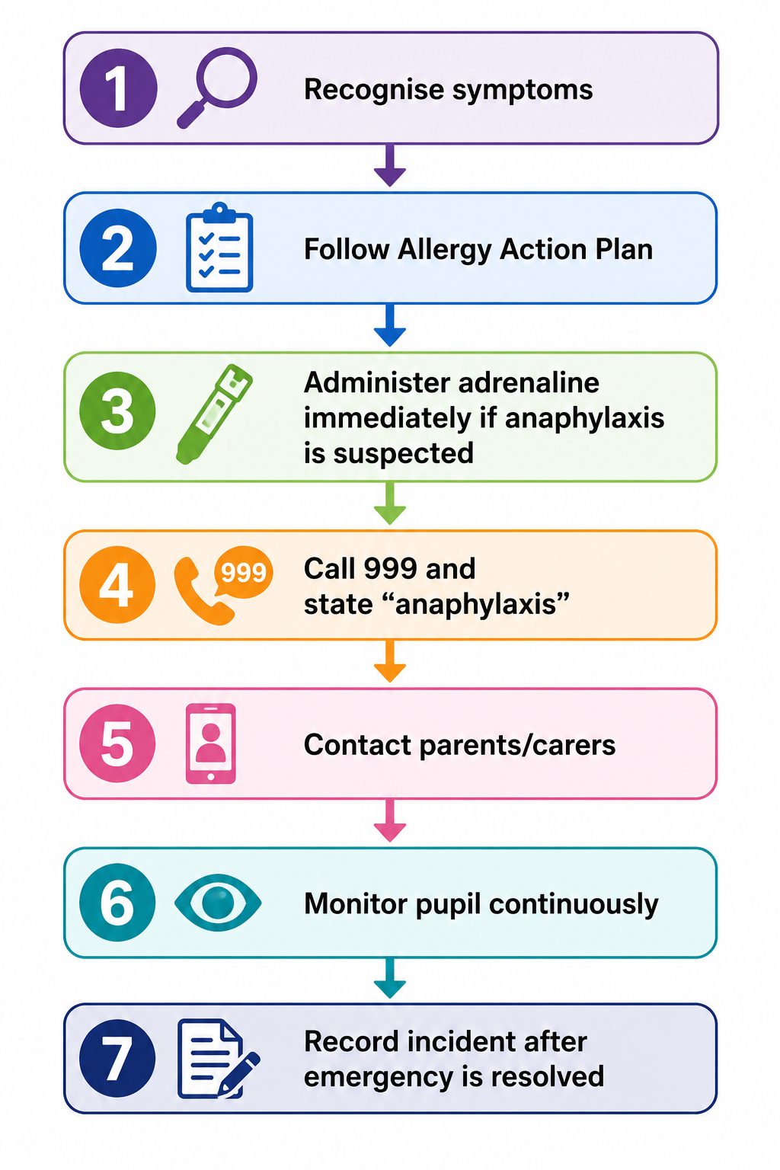

Appendix 2.
Chartwells Medical diet form


